# How to Alias a default aircraft in MSFS 2024

Native MSFS 2024 aircraft use a new file structure system where a common aircraft.cfg provides the title for all liveries of an aircraft variant. Livery addons will come with a new config file which does not contain the title tag FSE has used to identify aircraft in previous iterations of the simulator. Now that default aircraft are no longer encrypted, it is possible to modify the virtual file structure to change the common aircraft title tag to alias an aircraft and all its liveries to a different aircraft type in FSE. This is still achieved through the community folder by replicating a modified aircraft.cfg file. In this example we will Alias the default Beechcraft Bonanza as a Cessna 210.

## Limitations

The mod has not exhibited any significant limitations through limited testing. The most noticeable drawback appears to be MSFS 2024 not using the title in the same way that previous versions of the sim have. As a byproduct of forcing the title line to suit FSE, you can expect some oddities in the UI of the aircraft selection screen, although the model will show in place correctly still. I have also noticed that this mod breaks GSX integration, and some oddities with the tablets in the inibuilds Airbus series aircraft. Unfortunately, with the way the FSE clients work this is the best workaround option at this stage. Multiple test flights have been conducted with no ill effects identified in the way aircraft handle of FSE Flight data is recorded.

## Step 1 – Obtaining default file structure and aircraft.cfg

Default MSFS 2024 aircraft are still streamed into the simulator, as such we need to access the virtual file system to retrieve a copy of the aircraft.cfg and confirm its directory path. Note that this is a read only environment, and any file changes will be overwritten when the data is streamed in at next boot.

1. Enable the developer menu within the Settings > Advanced Options > Developer Mode

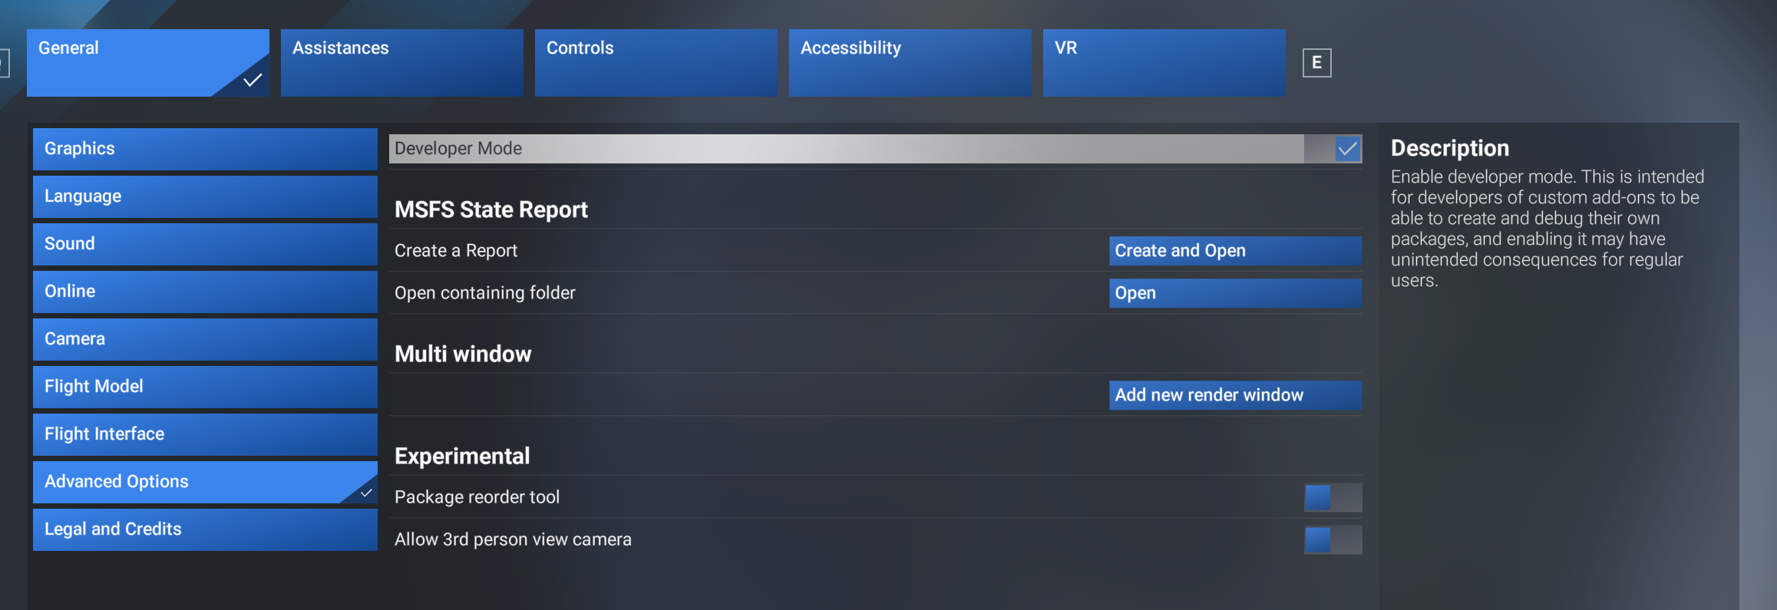

1. Open the Virtual File System from the Tools section of the developer tool bar

1. Select the VFS Projector option at the bottom of the pop-up menu for the Virtual File System

If this is your first time entering the VFS Projector, you will need to enable it to interact with Windows File Explorer by selecting the ‘Execute Command’ button.

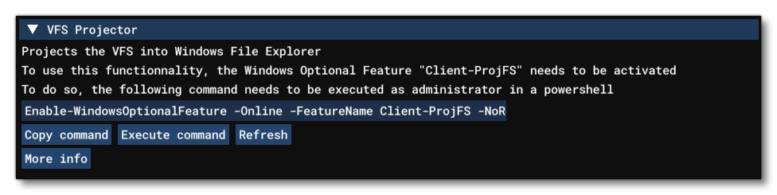

1. Run the VFS Projector by selecting ‘Start’ and then ‘Open in Explorer’

1. This will open your MSFS file structure with an additional ‘VFSProjection’ folder that contains the data currently being streamed into your Simulator. This folder is a read only environment and does not persist between sessions. Closing the simulator or selecting Stop on the VFS Projector will remove the folder and all content.

1. Navigate to the aircraft data folder of your target aircraft. All aircraft are within the SimObjects > Airplanes directory. In this case we are after the asobo_bonanza_g36 folder. Most default aircraft will either start with asobo_ or microsoft_.

Within the aircraft folder is typically 4 subfolders. The ‘Presets’ folder contains the aircraft.cfg files we wish to modify. There may be copies in some of the other subfolders however, presets is the only one reported to the FSE client and any duplicates in other folders may be ignored.

Within Presets is a single subfolder for the aircraft maker, asobo, inibuilds, carenado etc. We are then presented with the various aircraft sub variants for the model. If there is a specific variant you wish to modify, we can replicate this process once, otherwise you will need to repeat the following steps for each variant of the aircraft.

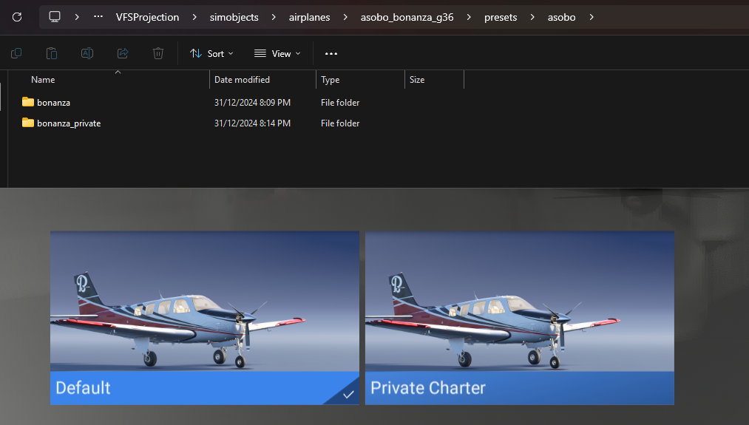

1. Within the variant folder, open config and you should now have the aircraft.cfg file accessible to you.

## Step 2 – Setting up a community folder entry

Now we have access to the aircraft.cfg file, we need to make a permanent copy which we can modify outside of the streamed file structures.

1. Open a new second file explorer window and navigate to your community folder. For MSFS 2024 the standard locations for the community folder are:

Steam:

C:\Users\{YourUsername}\AppData\Roaming\Microsoft Flight Simulator 2024\Packages\Community

MS Store: C:\Users\{YourUsername}\AppData\Local\Packages\Microsoft.Limitless_8wekyb3d8bbwe\Local\Cache\Packages\Community

Create a new folder in the community folder and title it as you see appropriate. In the example I have titled it ‘FSE Bonanza to C210’

1. Whilst we are in the root of the folder structure, we shall create the manifest.json and layout.json files required for MSFS to read our mod package. Right click on the empty space in your folder and select new > text document from the options.  
   A screenshot of a computer

   Description automatically generated

Name the new folder layout.json, and accept the warning prompt for changing the file type from .txt

1. Open the new file in a text editor such as notepad or notepad++ and copy in the template contents of the layout.json file:  
   

The only important element to change is the file path. We will obtain it by right clicking on the aircraft.cfg file in the VFS Folder and selecting ‘Copy as Path’. Paste this entry in place of the “Your File Path” element noting the quotation marks around the text have not been duplicated.

We now delete the beginning of the file path structure that refers to the VFS (highlighted) so it starts at ‘simobjects’. Save and exit the file.

1. We can now create the manifest file using the same methods as before to obtain a blank manifest.json. Open the file in a text editor and paste the following template:



You may wish to edit the title of the mod to something appropriate to your Alias project.

1. We now must replicate the folder structure within the VFS Projector for the aircraft we are modifying. In this case we need to make new folders to match ‘simobjects\airplanes\asobo_bonanza_g36\presets\asobo\bonanza\config’.

Once the folder structure is replicated, copy the aircraft.cfg file over to the new community folder entry. Once it is complete, right click and enter properties, then deselect the read only attribute for the file and click OK.

## Step 3 – Editing the aircraft.cfg Title

The next steps will be something seasoned FSE users are experienced with, but I will include them in an expanded manner anyway.

1. Obtain the title you wish to use from the FSE Aircraft Models page of the game website.

<https://server.fseconomy.net/aircraftmodels.jsp>

Select the aircraft type you wish to alias to, in this case a Cessna 210, and select ‘Request Aliases’

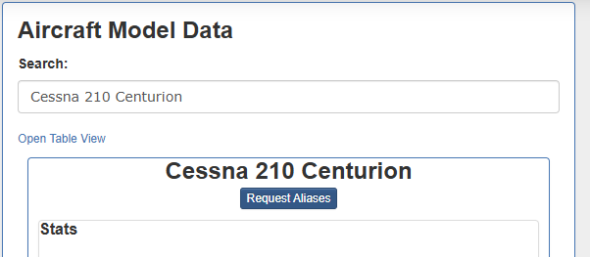

1. Select one of the titles arbitrarily and copy its text, in this case I have selected entry 19 on the list - Cessna 210 M Centurion II

In your community folder, open the aircraft.cfg and replace the existing title = text with the alias text you have selected. If you are not able to paste the data in, you may have skipped the step where we removed the read-only attributes from the file. Save and exit the file.

Your new mod should now be ready for use. Launching MSFS and reslecting the Bonanza, we can now see FSE Client detecting it as a Cessna 210. Also noticeable is the UI oddities discussed in limitations.

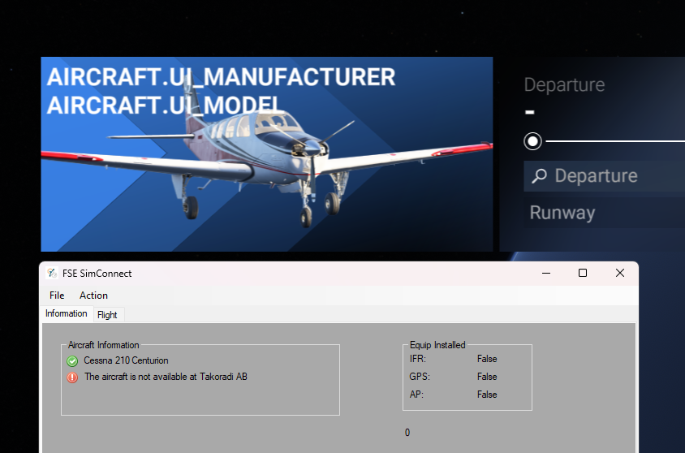

## Appendix

### layout.json

{

"content": [

{

"path": "simobjects/airplanes/asobo_bonanza_g36/presets/asobo/bonanza/config/aircraft.cfg",

"size": 176,

"date": 133801168626191670

}

]

}

### manifest.json

{

"dependencies": [],

"content_type": "AIRCRAFT",

"title": "FSE Bonanza to C210",

"manufacturer": "Beechcraft",

"creator": "FSE",

"package_version": "0.0.1",

"minimum_game_version": "1.0.88",

"minimum_compatibility_version": "0.88.0.40",

"builder": "Microsoft Flight Simulator 2024",

"package_order_hint": "",

"release_notes": {

"neutral": {

"LastUpdate": "",

"OlderHistory": ""

}

},

"total_package_size": "00000000000000004213"

}

### GitHub Example Files

The files for this example can be downloaded from GitHub  
https://github.com/N1K340/FSE-MSFS2024-Aliases/releases/tag/v1.0